National Kaohsiung University of Applied Sciences (KUAS)

About KUAS
Founded in 1963, National Kaohsiung University of Applied Sciences (KUAS) was originally known as the Provincial Kaohsiung Institute of Technology with the aim to educate technical professionals to meet the demands of national economic development. In 2000, the beginning of the new millennium, the Institute evolved to be a four-year technical university and the present name was adopted. This transformation from a junior college to a technological university has opened up a new page for KUAS. After more than a decade of development and expansion, KUAS has now reinvented itself as the leading technological university in southern Taiwan.
Currently, KUAS has four colleges offering top-quality undergraduate and graduate programs, serving more than 13,000 students and 100,000 alumni. The achievements of KUAS in teaching, research, and industry-academia collaboration have been highly recognized by the government. In 2012, KUAS received the grant for the “Plan for Developing Technological University Paradigms” awarded by the Ministry of Education (MOE). In addition, more than 10 research centers have been established on KUAS campus by the MOE and the Ministry of Economic Affairs, engaging in state-of-the-art research in a variety of fields. In recent years, over 500 industry-academia collaboration contracts worth more than NT$300 million have been signed between KUAS and the leading businesses and companies in Taiwan.
To meet the demands of globalized education, KUAS has recently in establishing international ties with institutions around the world. The university has signed MOUs with 123 partnering institutions in 13 countries to develop joint degree programs, student exchange programs and research collaboration. The partnerships are sure to bring new opportunities and enable KUAS to become a truly internationalized university.

Key Areas of Research and Development
•Smart electricity and electric vehicles
•Green architecture and smart healthcare Green energy and materials
•High speed communication networks and smart commerce and services
•Smart manufacturing and precision molding
•Cultural and creative cities and urban disasters prevention

School Performance
•The first university in Southeast Asia to receive the 1S09002 certification (1998)
•The first university in Taiwan to be awarded the TIPS certification (2008)
•The Incubation Center of KUAS was ranked first in the performance evaluation conducted by the Ministry of Economic Affairs for three consecutive years(2011-2013)
•KUAS was ranked first in the 2010 Technological University Evaluation conducted by the Ministry of Education (2010)
• The first university in Taiwan to offer MBA program for Vietnamese students (2003)

Degree Programs
National Kaohsiung University of Applied Sciences offers 10 four-year Bachelor’s, 16 Master’s and 6 Doctoral programs in four colleges (i.e. Engineering, Electrical Engineering and Computer Science, Management and Humanities) for international students. The number of recruits for each program is as follows.

College of Engineering
College of Engineering | Four-year  undergraduate | Two-year  undergraduate | Master Degree | Doctor Degree
Department of Civil Engineering | ● |  | ● | ●
Department of Chemical and  Materials Engineering |  |  | ● | ●
Department of Mold and Die Engineering |  |  | ● | ●
Department of Industrial Engineering and Management | ● |  | ● | ●
Department of Mechanical Engineering | ● |  | ● | ●

College of Electrical Engineering and Computer Science
College of Electrical Engineering and Computer Science | Four-year  undergraduate | Two-year  undergraduate | Master Degree | Doctor Degree
Department of Electronic Engineering | ● |  | ● | ●
Institute of Photonics and Communications |  |  | ●

College of Management
College of Management | Four-year  undergraduate | Two-year  undergraduate | Master Degree | Doctor Degree
Graduate Institute of Finance and  Information |  |  | ●
Graduate Institute of International  Business |  |  | ●
Department of Tourism Management | ●
Graduate Institute of Tourism and  Hospitality Management |  |  | ●
Department and Graduate Institute  of Business Administration | ● |  | ●
Department and Graduate Institute of  Wealth and Taxation Management  ※Wealth Management Division  ※Public Finance and Taxation Division | ● |  | ●
Department and Graduate Institute of
Accounting

Department of Information Management | ● |  | ●

College of Humanities and Social Sciences
College of Humanities and Social Sciences | Four-year  undergraduate | Two-year  undergraduate | Master Degree | Doctor Degree
Department of Cultural and Creative Industries |  |  | ●
Department of Applied Foreign  Languages | ● |  | ●

KUAS Scholarship

Full/Partial Scholarship：
- A scholarship not exceeding NT$6,000 per month is awarded for registered, full-time doctoral students. Waiver of tuition, dormitory fees and credit fees (No more than 12 credits).
- A scholarship NT$3,000 per month is awarded for registered, full-time master degree students. Free tuition and credit fees (No more than 12 credits).
- A scholarship not exceeding NT$1,000 at the most per month is awarded for registered, full-time undergraduate students. Free tuition and credit fees (No more than 12 credits).

Assistanceship：
- International students are required to apply for scholarship to the department.

- Regulations for stipend application, including Teaching Assistant, Research Assistant, Application qualification and Job responsibilities, will be determined by the Scholarship Committee for KUAS International Students.
- Applications will be evaluated and reviewed by the KUAS Scholarship Committee for scholarship eligibility.

To Complete scholarship Application:
(a) Scholarship Application form (DOWNLOAD from ATTACHMENT)
(b) One resume written in Chinese or English
(c) Highest level of education school report written in Chinese or English
(d) Submit a copy of national test certificates (optional)
(e) Two recommendation letters written in Chinese or English
(f) Certificates of Language Ability(Mandarin and English)
(g) Other reference documents

Apply for KUAS：
KUAS Application forms (DOWNLOAD from OIA KUAS website: http://oia.kuas.edu.tw/bin/home.php)

Select courses.
Take guidance.
EX. Freshmen training, healthy insurance, scholarship, etc.
Enrollment is done.
Keep studying.

Submit the application form to OIA by email:
qcoffice01@kuas.edu.tw
and apply online: http://140.127.112.2/kuasoia/login/
before late April or late October.

The forms are examined by departments.

Notification of Admissions and Enrollments

Arrival in KUAS
Registration of dormitory

• Spring 2015(Enrollment in February, 2015)
Events | Date
Application Submission | October 1--November 15, 2014
Application Deadline | November 15, 2014
Application Review and Evaluation | November 18--December 16, 2014
Notification of Acceptance | December 27, 2014
Registration | Mid-February, 2015

Fall 2015 (Enrollment in September intake, 2015)
Events | Date
Application Submission | March 24-- May 9, 2015
Application Deadline | May 9, 2015
Application Review and Evaluation | May 12--June 6, 2015
Notification of Acceptance | June 16, 2015
Registration | Mid- September, 2015

•

Tuition and other fees
The listed tuition and fees apply only to the 2014 Fall semester. The tuition and fees are adjusted annually.

Rates College | Tuition & Miscellaneous Fees | Fees per credit
College of Engineering | NT$24,946 | NT$2,984
College of Electrical Engineering and Computer Science | NT$24,946 | NT$2,984
College of Management | NT$21,194 | NT$2,984
College of Humanities and Social Sciences | NT$21,194 | NT$2,984
    - Graduate Programs (per semester)

    - Undergraduate Programs (per semester)

Rates College | Tuition | Miscellaneous Fees | Total
College of Engineering | NT$32,052 | NT$20,506 | NTD$52,558
College of Electrical Engineering and Computer Science | NT$32,052 | NT$20,506 | NTD$52,558
College of Management | NT$31,766 | NT$13,862 | NTD$45,628
College of Humanities and Social Sciences | NT$31,766 | NT$13,862 | NTD$45,628

Transportation of KUAS

Chien Kung Campus Yan chao Campus
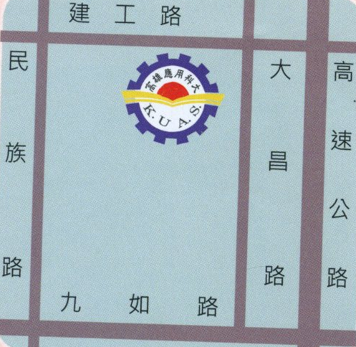
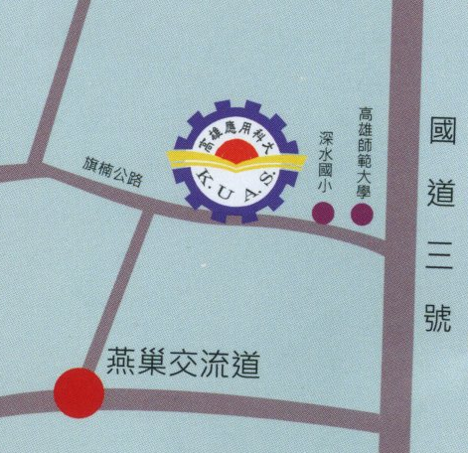

- Contact

Chien Kung Campus : No.415, Chien Kung Rd., Sanmin Dist., Kaohsiung City 807, Taiwan (R.O.C.)

Yanchao Campus : No.58, Shenzhong Rd., Yanchao Dist., Kaohsiung City 824, Taiwan (R.O.C.)

Tel：+886-7-3814526#2730~2740
E-mail：qcoffice01@kuas.edu.tw
International Cooperation Division: qboffice01@kuas.edu.tw
International Student Division: qcoffice01@kuas.edu.tw
Website：http://www.kuas.edu.tw

KUAS TAIWAN

